Second piloting report

Deliverable 2.8.1

SmartZoos project

Terje Väljataga

Tallinn University, School of Digital Technologies
Södertörn University
Helsinki Zoo
Skansen
Tallinn Zoo
2018

1. Introduction

The main objective of the SmartZoos project is to integrate the Zoos of the Central Baltic region into a joint tourist attraction through developing a cross-border service package of creative adventure learning with mobile devices. The service package includes:
- an online tool for creating interactive assignments
- an online repository of interactive assignments
- an online environment (Web platform + mobile clients) for composing and conducting location-based adventure games, challenges and tournaments

The deliverable provides an overview of the second prototype of an online tool for creating interactive assignments and its second piloting results.

2. Overview of the SmartZoos online tool

SmartZoos service package

SmartZoos is following the principle that visitors will be able to enrich the experience of visiting the zoos with their mobile devices in two ways:
- to accept challenges and games created by other visitors;
- to allow visitors to design and create challenges and adventure games for other visitors.

The SmartZoos technical solution is based on the PHP framework Laravel, Node.js and Gulp. The Google Maps API is used for the maps layer and the user interface is based on Bootstrap. The platform will make use of the open badges framework for recording the achievements of players.

The second prototype of an online tool (see Figures 1) is quiz-based: a set of questions (“activity”)—each multiple-choice, image-matching, or other type of puzzle (“activity item”)—appropriate to the game level of the player, is retrieved from the repository and presented on a map for the player to solve. The questions can be either randomly selected from the repository, or sorted as a trail with a specific purpose. Successfully answered quizzes gain points for the player.

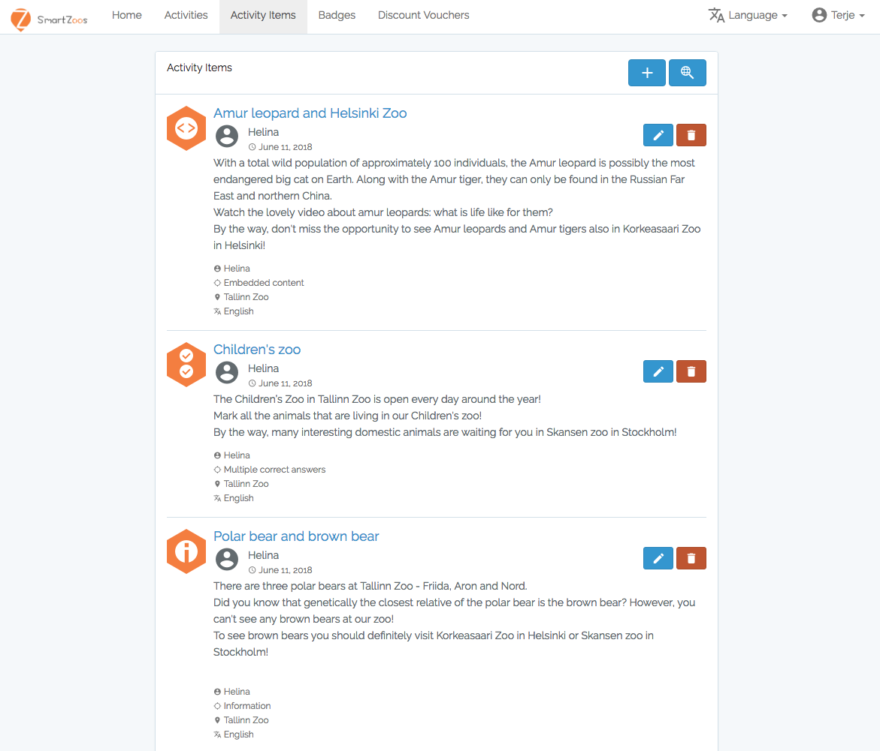
Figure 1. Screenshot of the SmartZoos tool: list of games

The online tool for creating adventure games can be found here: https://smartzoos.eu/
and its development progress can be followed here: https://github.com/SmartZoos/Toolset

3. Second piloting of the SmartZoos service package

Methodology

In order to test the applicability of the second prototype of the SmartZoos service package, a series of pilot studies were carried out in three zoos (Skansen, Helsinki Zoo and Tallinn Zoo) with different age and gender groups. The overall methodological framework for designing and developing the service package for knowledge building in zoos followed a research-based design approach (Leinonen, 2010). According to this approach, the overall design and development process of the SmartZoos service package started with an in-depth contextual inquiry (Figure 2). The second phase of the research-based design process focused on several participatory co-design sessions to get input from various stakeholders with direct focus on practical design of the service package. To give a more concrete form to the ideas presented in the earlier stages of the design and development process, in the third phase, the results from the contextual inquiry and particularly from the participatory co-design sessions were translated into a working prototype of the service package. After finalizing the production of the software as hypothesis in the fourth phase piloting the service pacakge in a natural setting (zoos) with potential users was carried out in spring and summer months 2018.

The data was collected through semi-structured questionnaires, observations notes and reflection sessions after using the SmartZoos service package. The objective of the data collection was to find out the users overall experience and opinions while using the SmartZoos service package, as well as their challenges and usability of the whole toolset.

Results of the second pilot studies

Usability of the SmartZoos service package and the users experiences
The overall experience of the test users in three zoos with the SmartZoos service package was rather positive. The users claimed that it was fun to play the games with their mobile phones (all age groups) and they appreciated the idea that there was the possibility to choose a game from the repository. Playing an adventure game while visiting a zoo was considered a nice alternative to the aimless wandering in the zoo. The grown-up users of the pilot studies brought out that the SmartZoos service package made them notice things that they would otherwise miss, helped them to learn and investigate many new things as the application provided some structure. The interface of the SmartZoos application was considered easy and intuitive to use and the users liked the idea that there were many games to choose from.

Furthermore, as the zoo educators designed the games, the questions and assignments in the games were meaningful and with good quality. The users also pointed out that as the toolset offers a set of different question types, it makes the game playing even more interesting because you are asked to do different tasks in the location points of the game. For instance, one has to take a picture in order to answer the question in a particular location point, sometimes one has to match pairs or choose the right answer one from the list of options. The users also considered the instant feedback after submitting the answer as a very positive functionality. The users were immediately notified whether their answer was wrong or right, however, some of the users suggested to provide more information to the users in case of the wrong answer.

One of the main usability challenges for the users was the fact that if one is not logged in to the game and decides to reload the game, one has to start over from the question number one of that game. So either the user has to sign in and then can reload the game or play as an anonymous user, but has to take into account the fact that reloading the game directs you in the beginning of the game.

Finally, the observers noticed that the adventure games should be designed in a very smart way not to invite the users to watch their mobile phones constantly, but include for instance, some observation tasks in between the location points of the game. That way the users are “forced” to look around while going from one location point to another one.

Technological challenges while using the SmartZoos service package
As expected, the users reported some technological issues as well. It turned out that the GPS signal and different models of mobile devices act differently and the GPS signal sometimes jumps, which means that one cannot answer the question. Here the back-up plan is to make use of a back up code, a functionality that was designed into the second prototype of the SmartZoos application. Due to the fact that the application is a web-based solution, it is not possible to make the GPS signal very precice and stable all the time. One has to take into account also the surrounding, trees, hills, buildings, which all influence the GPS signal.

While playing the adventure games, the users with older phones reported that their phones didn’t load the game, however, the users also admitted that they had problems with other activities as well (not only the game). To conclude, developing technological solutions always carries a threat that this technology doesn’t work always very properly, however, the collected data demonstrated that in most of the cases the users were able to solve their technological issues by consulting with their peers (58,3% of respondents) or solving them by themselves (41,7% of respondents). Younger users tended to ignore more often the emerging technical problems and just continued with the game.

Possible further developments
Although the overall experience with the SmartZoos application was positive, however, the users pointed out a few important aspects that could be considered in the future. For example, when playing the game in groups only one person could make an account of the SmartZoos and had to submit the answer in every location point. Furthermore, while creating questions in location points it turned out to be rather challenging to edit the question later. The users also pointed out that while playing the game they didn’t get a complete feedback in case of a wrong answer. The users expected to see the correct one after submitting the wrong answer.

A functionality that was considered important for the adventure game creators was the whole track view after finishing creating the game. Currently this feature is not available and the whole game can be visually displayed only when starting playing the game. It was proposed that there should be possibility to identify and choose in which order questions open and when extra information appears and to start the game from different locations. Furthermore, some of the users noted that it was difficult to find some points and that movement trajectory could take into account Zoo’s pathways not direct movement. This is a feature, which has two sides, on the one hand showing the actual path from one location point to another one defines users routes, on the other hand, if the route is left open, the users can choose the shortest or the most interesting one to the next location point. This way the users perceive freedom to make decisions and control over their activities.

Tips and tricks for the users of the SmartZoos service package
The game creators have to take into account that not every user has an unlimited data package, thus, the location points in the game should be located in areas where users can use the zoos wifi connection. Furthermore, the game creator should always provide a code in every location point to access the assignments in case the GPS signal jumps and doesn’t display players location properly. The game will be more enjoyable if it is created with meaningful and coherent location points and tasks in every location point. To guarantee the success of the game, it is recommended to be logged in to play the game. In addition to the gamified experiences the SmartZoos service package offers, the zoos can use it also as a guided tour around the zoo, where people only get facts about the animals at different points.

References

Leinonen, T. (2010). Designing learning tools. Methodological insights. Jyvaskyla, Bookwell Ltd.

